VIRTUAL LABORATORY: AN ALTERNATIVE APPROACH TO URBAN TRANSPORTATION SYSTEMS PLANNING LABORATORY

Ritesh Sharma
Research Assistant, Department of Civil Engineering
Indian Institute of Technology Bombay
Powai, Mumbai - 400076, INDIA
Ph.: +91-22-2576-7308; fax: +91-22-2576-7302
Email:riteshsharma@iitb.ac.in

Shital S. Jadhav
Research Assistant, Department of Civil Engineering
Indian Institute of Technology Bombay
Powai, Mumbai - 400076, INDIA
Ph.: +91-22-2576-7308; fax: +91-22-2576-7302
Email:shitaljadhav@live.com

Debabrata Tripathy
Research Assistant, Department of Civil Engineering
Indian Institute of Technology Bombay
Powai, Mumbai - 400076, INDIA
Ph.: +91-22-2576-7308; fax: +91-22-2576-7302
Email:debabratatripathy@iitb.ac.in

Harshala V. Sardar
Research Assistant, Department of Civil Engineering
Indian Institute of Technology Bombay
Powai, Mumbai - 400076, INDIA
Ph.: +91-22-2576-7308; fax: +91-22-2576-7302
Email:harshalavs@iitb.ac.in
Gopal R. Patil, Ph.D.
Assistant Professor, Department of Civil Engineering
Indian Institute of Technology Bombay
Powai, Mumbai 400076, INDIA
Ph: +91-22-2576-7308, Fax: +91-22-2576-7302
Email: gpatil@iitb.ac.in

Submitted for the presentation at the 93rd Annual Meeting of the Transportation Research Board and publication in the Transportation Research Record

Number of Words =3916, Number of tables =0, Number of Figures =12
Total Words Count= 3916+12*250= 6916
Submission Date: August1st, 2013

ABSTRACT
The significant advancement of internet technology has made it possible for users to access laboratories located at distant places with the help of a virtual platform. This paper presents Urban Transportation Systems Planning Virtual laboratory, one such platform, where users can access the experiments based on Urban Transportation System Planning (UTSP) course. UTSP is one of the important courses for a master’s degree in Transportation Engineering. Implementation of the problems covered under this course is quite computationally intensive and the experiments are usually performed using commercial tools like TransCAD or Cube Voyager. These tools are expensive and are not affordable by most engineering colleges in India. Additionally, extensive training is required to learn these tools. This laboratory aims to provide users with an interactive graphical user interface for performing and evaluating the experiments in the field of Transportation Demand Modeling. To provide such an interactive and realistic graphical user interface for virtual environment, it has been designed using freely available software platforms such as JRE 1.7, Apache, PHP and MySQL. The scalability and interactivity of this laboratory are realized using client server architecture where a user only needs simple java-enabled browser to access the laboratory located at a different location. At the end of the paper, feedback and self-evaluation results have been presented to assess the quality of both UTSP Virtual Lab and the learning imparted by the lab to its users.
KEYWORDS

Virtual Laboratory (VLab), Urban Transportation System Planning (UTSP), web-based user interface.

INTRODUCTION
Experimental learning is an effective process through which students develop required skills for the practical implementation. This helps to understand the practical implications of the theoretical concepts acquired in the classroom environment. To perform experiments sophisticated laboratories are required. Time and money required for planning and development of sophisticated laboratories has always been beyond the reach of many institutions. There are also vast differences in availability of infrastructure, skilled staff and teachers (1). In a highly populated country like India, it is always a major problem to provide sophisticated laboratories, both in terms of quality and quantity. In order to fulfill such needs, the Ministry of Human Resource Development (MHRD), Government of India, initiated the project “National Mission on Education through Information and Communication Technology (NME-ICT)”.This is another initiative by MHRD after the successful implementation of the nationwide program, National Program on Technology Enhanced Learning (NPTEL)(2). In this project the reputed institutions across the nation collaborate to create, design and implement Virtual Laboratories with the aim to enhance and support practical experimentation among the undergraduate, post graduate and researchers (3). This paper presents development of Virtual laboratory for Urban Transportation System Planning (UTSP) Course. In UTSP laboratory assignments, the travel demand models are developed with the help of commercial software tools such as TransCAD and Cube Voyager. These tools are very costly and beyond the reach of the teachers and students in most of the engineering colleges of India. Only some reputed institutions in India own these software tools. Even if an institution owns these tools, they are not of much use for teaching an algorithm or a methodology. These tools usually give the final outputs given certain inputs for an experiment, without much interaction with the users. Learning to use these tools is time consuming and thus is not much useful for teaching.
UTSP is a one of the core course for a master’s program in Transportation Engineering in most of the reputed universities namely, Indian Institute of Technology Bombay(4), Massachusetts Institute of Technology, University of Illinois Urbana Champagne(5), University of California Berkeley(6), University of Massachusetts Amherst(7), etc. The four-stage travel demand model constitutes a major part of this course. Other course titles such as travel demand modeling or transport demand modeling have similar contents. Many universities in India and other countries teach the travel demand modeling to undergraduate students also.
After the success of distance learning through Information and Communication Technology (ICT), the interest for practical experimentation rose up among the researchers and educationists. Practical experiment has a tremendous importance in engineering education. It provides students with the better understanding of the courses, which are quite difficult to grasp in a closed classroom environment. The main objective behind performing experiments in engineering education is to relate the theoretical concept with the practical implementation in real world. But to provide such sophisticated laboratory to each and every individual across the nation is always a problem. Thus creating a geographical barrier between laboratories and students. Providing equipments to each and every student to perform experiment according to their level of efficiency is also one of the issues (8). The study presented by Kennedy (2002) shows that the geographical distance is not the only factor in providing access to education, but there are other factors too responsible for effective education (9). Also, the laboratories where time and space are limited, it becomes difficult for many students to learn with the pace with which a laboratory instructor instructs. Cognitive distance and Role distance are other barriers which a student and the instructor have to face in classroom setting. Kennedy (2002) defined Cognitive distance on the basis of understanding. Every individual have different level of intellect which makes it difficult for the student to grasp each instruction in a time bounded lab hours. Role distance is the gap in status which exists between a students and the instructor within the institution which makes it difficult for students who are low in confidence while asking doubts in a classroom environment. To overcome these issues in traditional educational system, the need for creation of virtual laboratory comes into picture.

VIRTUAL LABORATORY
A Virtual Laboratory (VLab) is broadly defined as ‘an electronic workspace for distance collaboration and experimentation in research or other creative activity, to generate and deliver results using distributed information and communication technologies’ (10). It is an important educational tool that enables sharing of data, videos, etc. among the users. It provides virtual environment to perform experiment. It is far more superior to real laboratories in terms of saving experiment costs, trial and error flexibilities, providing safe and suitable environment, etc. The audio and video provided in the experimental procedure section allows a user to learn and perform experiments, thus facilitating the understanding of entire simulation process of the experiment. Though it cannot replace the real laboratories as a whole but it will surely provide a supplement to it.
The University of Hagen (German: Fern Universitat in Hagen) (11) in Germany and the Open University of Catalonia (UOC) (12) in Spain are entirely virtual universities. As both of the university being the virtual university and its entire student population consists of distant learner, they came up with the concept of virtual space where students can learn independent of their geographical locations. Such virtual space is called virtual laboratory. To come up with similar virtual universities in India, the MHRD, Government of India started the initiative (NME-ICT) with an aim to provide support for the creation of Virtual Technological Universities (VTU) in India as well.
A web based Virtual laboratory for mechanical engineering was developed in the Wuhan University of Science and Technology, Wuhan, China as a part of undergraduate lecture in mechanical engineering (13). In this lab, user interface, 3D models, motion simulation, etc., were used to create a virtual space for the students with little replica of the real lab environment. The client–server technology was used for the course on communication principles at the National University of Singapore (NUS) (14) to create virtual learning environment for distance engineering education. A web-based virtual environment for teaching qualitative analysis of structures developed at Trinity College Dublin provided student with interactive web-based teaching and assessment tool where student can vary their inputs to predict the deflected shapes of the loaded structures (15).
Li et al, (16) classified the web based virtual laboratory into three types: software-sharing based, equipment-sharing based and remotely instrument-controlled based.
In software sharing based labs, a web server is assigned to receive requests from the client, perform the simulation process and returns the response to the client. In equipment sharing based VLab, web server is not only assigned to receive request from the client but also uses experimental parameters passed by the client to configure experimental equipment connected to the hardware on the server side. Lastly, the third type of VLab is the one which uses the experimental inputs provided by the client to control the hardware present on the server side. UTSP VLab falls under the first type, where only simulation software is shared.
Virtual laboratory allows student to perform experiment repeatedly if they don’t understand for the first time. It helps students in saving time and travelling expenses by providing them remote access to the laboratory. A well designed Virtual laboratory not only improves accessibility, it also provides a better way to explain the difficult theoretical concepts (17). Apart from advantage there are some disadvantages as well. Too much reliance on the virtual laboratory can under prepare students for industries. They might not be able to understand the expensive software which industry standards require. Though the instructions are provided still student might not understand the underlying concept behind the experiments due to lack of the immediacy of the supervision and contact with experienced professors (18). On the technical side, virtual laboratory has many technological drawbacks. As it runs over a server maintained at a distant location, sometime the server may not be available for service due to failure. Also, the upgrade of browser software or server can make virtual laboratory dysfunctional. It requires regular maintenance.

UTSP VLAB IMPLEMENTATION
Urban Transportation Systems Planning (UTSP) is a core course in the field of Transportation Engineering. Modeling of travel demand is the key aspect of transportation planning. In order to evaluate the present and future performance of an urban transportation networks and to plan for the future infrastructure requirement, a demand model is developed for each urban conglomeration. It starts with defining the study area and dividing them into a number of zones and considering the entire transport network in the system. The database typically includes the current (base year) level of population, economic activities like employment, shopping space, educational, and leisure facilities of each zone. The classical model is presented as a sequence of four sub models: trip generation, trip distribution, modal split, and trip assignment shown in figure 1. It involves descriptive and mathematical analysis of given scenario in different stages and sub stages and thus making it difficult for students to interpret various step and outputs. To simplify these basic concepts graphical user interface becomes a necessity for the user to understand these facts and help them to co-relate the significant mathematical output with the real scenario. Ortuzar et al, have presented a detailed discussion of four stage demand modeling in his book (19).
The first step of the traditional travel demand modeling is trip-generation, which uses socioeconomic data to estimate both the total number of trips generated and attracted by each zone. The majority of trip-generation studies require multiple regression analysis to develop the prediction equations for the trips generated by various types of land use. Stepwise regression analysis programs allow the analyst to develop and test a large number of potential regression equations using various combinations and transformations of both the dependent and independent variables. Category analysis is a technique for estimating the trip production characteristics of households, which have been sorted into a number of separate categories according to set of properties that characterize the household.
The next step is the allocation of these trips from each zone to various other destination zones in the study area using trip distribution models. The output of the above model is a trip matrix, which denotes the trips from each zone to every other zone.
In the succeeding step the trips are allocated to different modes (car, two-wheeler, transit, walk, etc.) based on the modal attributes using the modal split models. It divides the trip matrix for various modes generated to a mode specific vehicle-type trip matrix.
In the last step, called as traffic assignment, each trip matrix is assigned to the route network of that particular mode using the trip assignment models. There are the different types of traffic assignment models, such as, All-or-nothing, User-equilibrium, System-optimal assignment, Stochastic assignment and Dynamic assignment. The primary output of traffic assignment are the link flows from which other outputs such as travel time, emissions, etc. can be derived.
ZONE NETWORKS
BASE-YEAR DATA
FUTURE PLANNING DATA
DATABASE
BASE YEAR FUTURE YEAR

TRIP GENERATION
TRIP DISTRIBUTION
MODAL SPLIT
TRIP ASSIGNMENT
EVALUATION
FIGURE 1 Classic four stage transport model

SYSTEM DESIGN

Experiment Structure
UTSP VLab is broadly divided into three phases namely, Pre-Experimental Phase, Experimental Phase and Post-Experimental Phase. In Pre-Experimental Phase, the user uses modules like, aim, theory, and procedure to understand the underlying objective and theory behind the experiment. In Experimental Phase, the experiment simulator provides the user with a virtual platform for performing the experiment. In post-experimental Phase, the user appears for self-assessment test based on the performed experiment and gets the feedback. The detailed modules as shown in figure 2 are discussed below:

Aim
The objective of the experiment is provided under this module.

Theory
This module explains the underlying theory about the experiment.

Procedure
This module provides the structured procedure along with a video for the understanding of the entire process of conducting the experiment.

Experiment
Two types of simulators are provided in most of the experiment namely, PHP-based simulator for small dataset and Applet based simulator for large dataset.
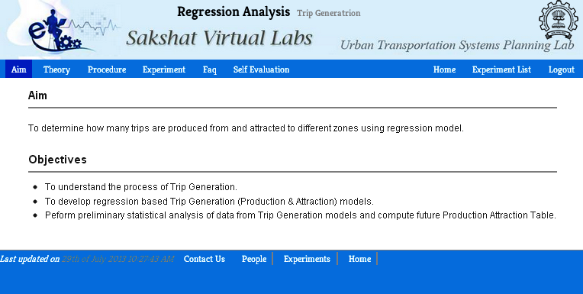
FIGURE 2 Snapshot showing modules of the experiment.

Frequently Asked Questions
This module provides answers to some underlying concepts associated with various experiments.

Self Evaluation
The self-assessment test comprises of question related to experiments. It helps user to assess their understanding on the theory and the task performed for each experiment.

Feedback
A continuous assessment of user accessibility and understanding of concepts is done via feedbacks from all users and thus help the developers in making the UTSP VLab more useful.

Procedure of Experimentation
The flow of the entire experimentation process is given in figure 3. In order to perform an experiment, a user has to register for the virtual lab and login using a secured username and password.
After logging in, the user can see a list of experiments. The user can then choose any experiment from the list. Each experiment contains Aim & Objectives, Theory, Procedure, Experiment, FAQ, Self Evaluation and Feedback as different modules under the experiment. In order to get familiarize with the entire experimentation procedure, the user can go through different modules available under the experiment.
After acquiring the pre-requisite knowledge of the experiment, the user can go to experiment tab to perform the experiment. Under the experiment tab, there are two simulators, PHP-based simulator or JAVA-based simulator, and sample input files. A sample input file is provided for user to get them started with the experiment. UTSP VLab also provides the flexibility to users to use their own input file in both simulators. For large dataset, Java-based simulator is usually recommended. The results obtained after the experiment can be saved in either Microsoft excel (.xls) or in portable document format (.pdf). The UTSP VLab is presently available online at http://www.civil.iitb.ac.in/~gpatil/utsp_vlab/ .
Results
User
Yes
No
Homepage
Login
Aim
Is Authorized?
Theory
Procedure
Perform Experiment
Self Evaluation
FAQ
Experiment Module
Feedback
PHP-Based Simulation
JAVA-Based Simulation
Register
FIGURE 3 Flowchart of the procedure for performing experiments.
System Requirements
Technically, the following requirements are to be fulfilled before running this VLab both as client and server.

Client Side
In order to perform experiment in UTSP VLab, the user’s browser must have java enabled along with JRE version 1.7 or above installed on the system. The procedure for the installation is also provided below the list of all experiments. PHP-based simulators can run independently regardless of any operating system.

Server Side
The server requires PHP, APACHE and MySQL to be installed on the server machine. We have a server with all the requirements which is working and the experiments can readily be performed from any computer having internet connection.

Architecture
The UTSP Virtual Laboratory is based on Client-Server Architecture as shown in figure 4.
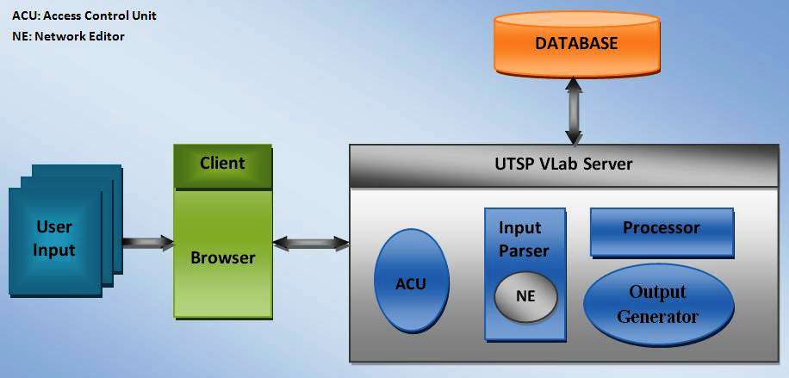
FIGURE 4 Architecture of UTSP Virtual Laboratory.
The communication between client and server are based on TCP/IP Protocol. It occurs in the following steps:
  - The user requests UTSP VLab Server through GUI (running on the web browser of client machine).
  - UTSP VLab Server receives information and authenticates with the help of Access Control Unit (ACU).
  - ACU authenticates the user by sending a query to database.
  - After the authentication request passes to processor through input parser.
  - Processor runs the simulation and sends results to Output generator.
  - Output generator prepares output and sends back to the client which then appears on the GUI.

Tools Used
The entire system is developed using the following tools:

PHP
PHP is open source software released under the PHP License. It is a server side scripting language. It is basically used in web development to produce dynamic web pages. PHP script can easily be embedded into HTML and can be processed by a web server with a PHP processor. It also has capacity to include a command-line interface, which helps in running .exe file in simulation engine. PHP can run SQL query as well, which are needed to access the contents of experiment stored in database.

Java
Java is a general-purpose, concurrent, class-based, object oriented language. The syntax of Java is derived from C & C++. The code developed in Java can run on any platform without the need of recompilation on another machine once it is compiled on the source machine. Most of the experiment also have Applet simulator which are developed on JRE 1.7 or above.

Apache
APACHE is high performance HTTP server software. It supports many compiled modules that extend the core functionality. It can handle multiple requests in reasonable time frames, which are one of the requirements of the VLab.

MySQL
MySQL is open source relational database management system software. It is used to store the entire content of the experiment.

FEATURES
The UTSP VLab has been designed with following goal and features as mentioned by Benetazzo et al.(16).

Educational Goals

Initial Orientation Towards Experimentation
UTSP VLab support key aspects of UTSP course and faculty teaching in order to enhance student’s knowledge and familiarize them with basic fundamentals of experiment. No prior technical knowledge or expertise of software handling is required to perform experiment.

Type of Student’s/User’s Reachability
USTP VLab mainly focuses on providing quality experimental approach in a virtual environment at remote places where infrastructure is a major issue. Since a good teacher is always a scarce resource, UTSP VLab provides audio and video lectures developed under the supervision of experienced professors of reputed Institutions. This will enable the user to learn techniques and knowledge required to perform an experiment.

Easy To Use Graphical User Interface:

User Friendliness
The UTSP VLab provides a simple and easily understandable interface to the user (shown in figure 5(a), 5(b) and 5(c)). Knowledge of the programming language like PHP or JAVA is not needed to use the Graphical User Interface. It can run on any operating system.

Flexibility
UTSP VLab provides flexibility both in time and space. A user can access the VLab from any place as it runs on the internet technology. It is available 24 hours a day and thus user does not need to be strict with the time schedules.

Easy Navigability
UTSP Virtual Laboratory has been designed in such a way that user can navigate through different modules at any stage of experiment.

Easily Interpretable results
The results obtained from experiment on the UTSP VLab can be easily interpreted from the graphs and well explained visual results (shown in figure 5(b) and 5(c)). One of the added advantages of this VLab is that user can save the results in Microsoft excel (.xls) or in portable document format (.pdf).
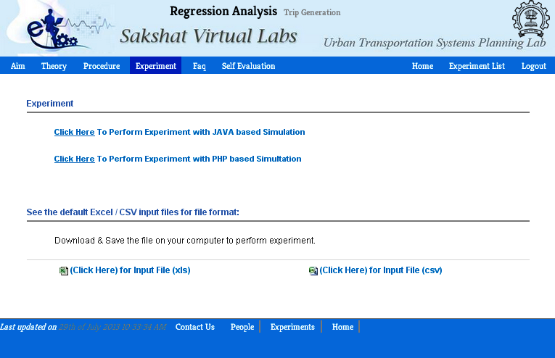
FIGURE 5(a) Graphical User Interface Showing Experiment Module.
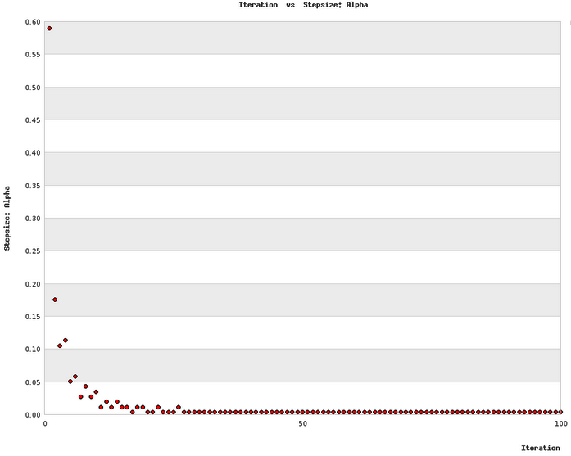
FIGURE 5(b) Interface Showing Plot Result for User Equilibrium Assignment taking step size as criteria for convergence.
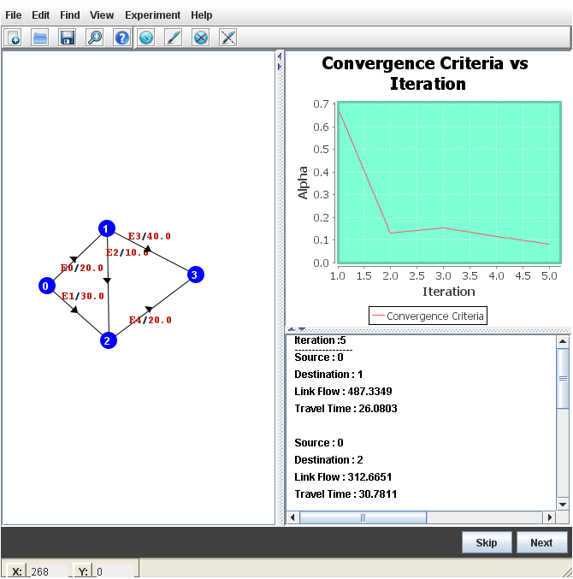
FIGURE 5(c) JAVA-based Graphical User Interface Showing Network Editor.

Cost Effective
The UTSP VLab has been designed on easily available platforms such as PHP, MySQL and Java. The entire coding or scripting has been completed in ECLIPSE. It runs on Client-Server architecture and uses internet as communication tool. It is a freely available application. In real UTSP Laboratory, students would require sophisticated softwares like Cube Voyager, TransCAd, etc. and softwares like SPSS, MatLab, etc for data analysis. These softwares are financially expensive and require training and practice to use them. VLab is a self-contained web application that does not require the understanding or learning of PHP or JAVA to use the graphical user interface.

Security

Session Technology
Session of each user accessing UTSP VLab is maintained by using session technology so that the unknown access can be restricted to some extent. If user does not uses the VLab for more than 20 minutes, then system automatically expires the session.

Login Authentication
Each user is authenticated through a secured username and password and thus the integrity and individuality of each user is maintained.

EVALUATION AND ASSESSMENT
The trials were conducted with a group of 30 students and 10 lecturers from different institutions in India. They were asked to perform experiment on their own and give their feedback based on their experience with the UTSP VLab. The important questions that they were asked to rate in the feedback form are as follows:
- To what degree do you think the actual lab environment simulated?
- Whether the manuals (Theory and Procedure) provided was helpful?
- Whether the results of the experiment were easy to interpret?
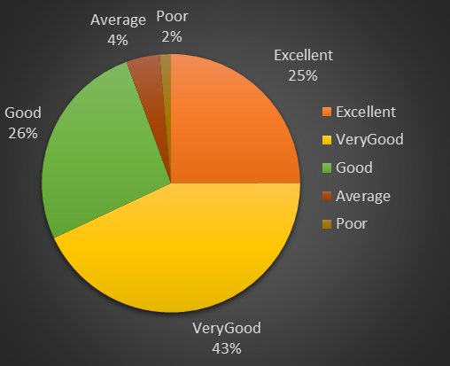
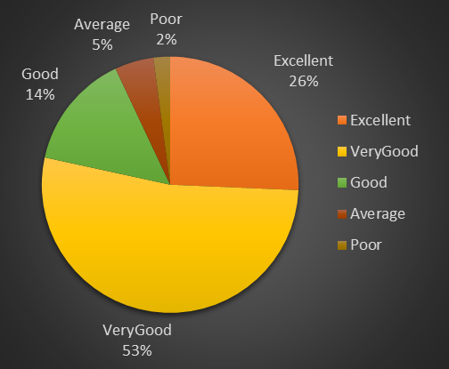
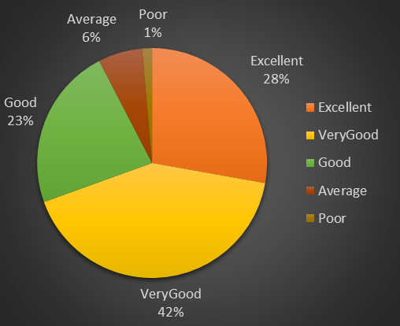
The results obtained were very encouraging and same can be seen in the figure 6(a), 6(b) and 6(c).The results shows that UTSP VLab can provide an aid to traditional way of teaching and experimentation for the urban transportation systems planning course. From the figure 6(a) it can be observed that about 95% of the users were more than satisfied with the environment the virtual laboratory provided them. The result obtained from the figure 6(b) shows that the content of the laboratory is above average according to approximately 92% of the users. Also, from the figure 6(c), it can be seen that the visual results and graphs obtained at the end of each experiment were quite easily interpreted by most of the users of this laboratory.

FIGURE 6 (a) To what degree do you think the actual lab environment simulated? (b)Whether the manuals (Theory and Procedure) provided was helpful?(c) Whether the results of the experiment were easy to interpret?
Figure 7 shows some more questions and its response that were asked from the user in the feedback form. About 87% of the user found the lab easy to use than the softwares used in the traditional laboratories. Approximately 76% of the user found their results and graphs obtained accurately matched with their results obtained by their manual calculations. More than 90% users found it easy to analyze the results for their study purpose.

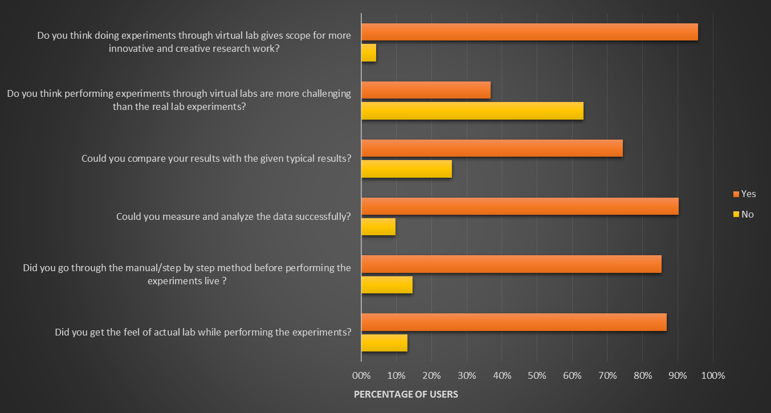
FIGURE 7 User responses to the questions asked in feedback form.
From figure 7, the behavior of the user can also be assessed. It was found that about 85% users followed step by step by step procedure to conduct their experiments. From the above result, it can be inferred that when users are not in compulsion of time bound schedule, they follow the steps accordingly without jumping off to the experiment directly. But when the users are in a hurry and have to finish their experiment within the permitted lab-access time, they have the tendency to skip the theory and thus obtain the bad results out of the experiments.
The success of this virtual lab can easily be assessed by observing the results obtained in the last question in the figure 7. About 87% of the users were satisfied with the kind of environment the lab provides them.
A group consisting of students pursuing postgraduate in transportation engineering were asked to go through the content of the experiments and evaluate themselves before proceeding to experiments. The students were unaware of the fact that their responses will be collected and will be used to evaluate the quality of the content provided for each experiment.
The result obtained from the self evaluation, shown in figure 8, are somewhat encouraging. From the result obtained, it is seen that 9 out of 10 students have given more than 50% correct responses. This clearly indicates the goodness of the quality of content which students were able to understand without the presence of instructor.
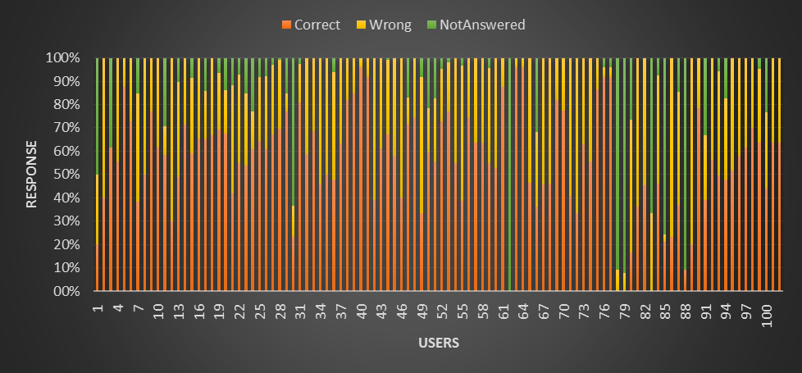
FIGURE 8. Self Evaluation Results
CONCLUSIONS
This paper presents UTSP VLab as an alternative to expensive softwares used for performing experiments related to Transportation Systems Planning course. The UTSP VLab is designed to provide a platform for performing Four Stage Travel Demand Modeling experiment without the need of any instructor or the need of expensive softwares like TransCad, Cube Voyager, etc.
The UTSP VLab is one such platform which is useful for both graduate and undergraduate students who wants to learn the traditional four-stage travel demand modeling without the need of instructor or traditional software. It can be implemented in any institution with minimum requirements at free of cost. It needs a system with a browser installed in it and an internet connection to work with. A web-based user interface of the VLab can be accessed from anywhere to perform experiments with minimal requirements on client computers. To make each experiment complete in all perspective, sufficient content has been provided with each experiments.
Users’ feedback presented in Figure 6 and Figure 7 clearly portrays the satisfaction of the users with the practical experimentation and content presented in the lab. Around 5% of users rate the virtual lab with the rating “Average” which gives us the scope to improve the virtual lab further making it more interactive and helpful to the users.
ACKNOWLEDGMENT
The work presented in this paper is a part of the project titled Sakshat Virtual Labs funded by Ministry of Human Resource Development (MHRD), Government of India. The authors would like to acknowledge the contribution of Mr. Amit Kumar Singh and Ms. Ankita C. Chaudhary for the development of UTSP VLab. The authors would also like to acknowledge the IIT Bombay Transportation Engineering Team for lending their support in the development.

REFERENCES
- Sheroy, T., and V. K. Gupta, Effective Virtual Laboratory Content Generation and Accessibility for Enhanced Skill development through ICT, International Association of Computer Science and Information Technology Press, Singapore, Vol.12, 2011, pp. 33-39.
- National Program on Technology Enhanced Program (NPTEL), Website http://nptel.iitm.ac.in
- Government of India, Ministry of Human Resource Development (MHRD), National mission on education through information and communication technology: mission document.http://www.sakshat.ac.in/pdf/missiondocument.pdf, Accessed July 10, 2013
- Urban Transportation System Planning Curriculum at Indian Institute of Technology Bombay, Website http://www.civil.iitb.ac.in/~dhingra/ce715.htm
- Urban Transportation Planning Course at University of Illinois Urbana Champagne, Website http:
- Transportation Planning Course at University of California Berkeley, Website http://www.ce.berkeley.edu/programs/trans/courses
- Transportation Planning and System Analysis course at University of Massachusetts Amherst, website http://cee.umass.edu/cee/grad-course-listing#transportation
- Benetazzo, L., M. Bertocco, F. Ferraris, A. Ferrero, C. Offelli, M. Parvis, and V. Piuri, J. C. Maxwell, A Web-Based Distributed Virtual Educational Laboratory, IEEE Transaction on Instrumentation and Measurement, Vol. 49, NO. 2, 2000, pp. 349-356
- Kennedy, M. D., Dimensions of distance: a comparison of classroom education and distance education, Nurse Education Today, Vol. 22, Issue 5, pg 409-416, 2002
- Rauwerda,H., M. Roos, Bob O. Hertzberger, and T. M. Breit, The promise of a virtual lab in drug discovery, Drug Discovery Today, Vol. 11, Issues 5-6, 2006, pp. 228-236.
- Fern Universitat in Hagen website, http://www.isdb.fernuni-hagen.de/index.php/en-/forschung/projekte/87.html, Accessed July 15, 2013.
- The Universitat Oberta de Catalunya Website. http://www.uoc.edu/web/eng, Accessed July 15, 2013.
- Ko, C. C., B. M. Chen, S. Hu, V. Ramakrishnan, C. D. Cheng, Y. Zhuang, and J. Chen, A Web-Based Virtual Laboratory on a Frequency Modulation Experiment, IEEE Transaction on Systems, Man, and Cybernetics-part C: Application and Reviews, vol. 31, 2001.
- Hou, Y., and F. Wang, Web-based virtual laboratory for mechanical engineering, 5th International Conference on Computer Science and Education (ICCSE), Aug. 24-27, 2010.
- O’Dwyer, D.W., T. M. Logan-Phelan and E. A. O’Neill, A web-based virtual environments for teaching qualitative analysis of structures, European Journal of Engineering Education, Vol. 32, No. 6, pg 695-709, 2007.
- Li, L., Y.Zhong, and S.Zhong, Research on the Design and Development of a Web-based Physics Virtual Lab for Junior High Schools, 2nd International Conference on Education Technology and Computer (ICETC), 22-24 June 2010.
- Nedic, Z., J. Machotka, and A. Nafalski, Remote Laboratories versus Virtual and Real Laboratories, Frontiers in Education Conference (FIEC), 5-8 Nov, 2003.
- Scheckler, R. K., Virtual Labs: a substitute for traditional labs, The International Journal of Developmental Biology (IJDB), Vol. 47, pg 231-236, 2003.
- Ortuzar, J. D., and L. G. Willumsen, Modelling Transport, John Wiley & Sons, Chichester, 1996.

Corresponding Author

